Broens,Michelle J.J.

GD43 | GTO4

Turn-based local battle

My project

Contents

Abstract 2

DOT-Framework Research Strategy 3

Library 3

Workshop 3

Lab 3

Showroom 3

Expected deliverables 4

# Abstract

The game that is going to be made is a game where the local battle between the players is the focal point. This will be done in a sort of turn based way, because there are a few limited resources like mana for example, this will be collected by defeating enemies who are constantly being spawned. The players can also influence the game by using skills.

The goal of the game is to defeat the other player, this can be done by using skills to thwart the enemy player from walking across the screen to the “finish”. The players both have a health bar and a mana bar. The health bar will be depleted by getting hit by skills form the enemy or by getting hit by enemies, if the health bar hits 0 the player loses. The mana bar will be depleted by using skills, but a player gets mana from defeating enemies.

# DOT-Framework Research Strategy

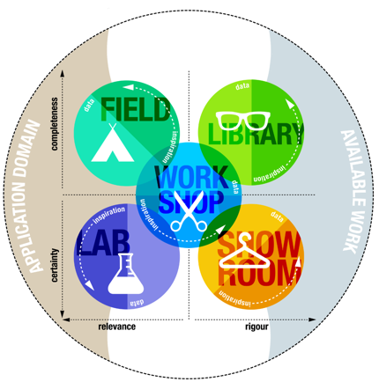

## Library

Start by analyzing similar games, stuff like Clash Royale. From this there will be a conclusion drawn to see what games like this have in common and what the most important requirements are.

## Workshop

A proof of concept will be made with use of the requirements, this proof of concept will be used to set up a paper prototype. The game will have integrated modules from the workshop to set up a basic structure.

During Game Design Basics we’ve paper prototyped this game and tried multiple things. This project is a continuation and digitalization of that game. We’ve tried an objective which you need to move across the map to obtain while the other player tried to stop you with skills. There were 4 rounds and the one who got the most objective points won the game. We’ve tested this game with multiple people and the game has changed multiple times. You can read more about this in the GDB document.

## Lab

The prototype made before will be tested on the intended users. From the results of these tests the core gameplay will be tweaked to satisfy the users.

## Showroom

Once the proof of concept is finished there will be a few peer review sessions with the fitting Community of Practice. The feedback from this will be collected and used to further improve the game.

# Expected deliverables

A functioning proof of concept with the following features:

* A simple design of the level
* Multiplayer “turn-based” core gameplay that will involve the players using skills to battle each other, this will involve a win/defeat condition.
* You must walk across the screen to keep collecting points (this is to stop players from standing still or camping in a safe space).
* A document that contains feedback from the users that have tested the prototype and/or paper prototype.